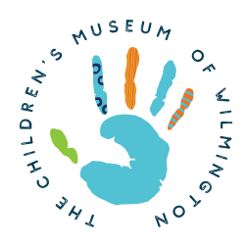Multi-lingual Communications Intern/Volunteer Wilmington, NC

5-10 hours a week

The Children’s Museum of Wilmington
The Children’s Museum of Wilmington has been serving the greater Wilmington community for over 23 years. Our mission is to provide a welcoming and engaging environment that promotes hands-on art, science, and literacy-focused learning for children and families.

Job Summary:
The multi-lingual Communications Intern will assist with translating Museum communications to Spanish, reproducing documents, as well as, transcribing website materials and graphics.

Responsibilities

- Assist with written and spoken translation and editing
- Translate the Museum’s social media updates
- Assist with translating new and past projects

The above statements are intended to describe the general nature and level of work being performed. They are not intended to be an exhaustive list of all responsibilities and duties required. The Children’s Museum of Wilmington is an Equal Opportunity/Affirmative Action employer. All qualified applicants will receive consideration for employment without regard to sex, gender identity, sexual orientation, race, color, religion, national origin, disability, protected veteran status, age, or any other characteristic protected by law.

Qualifications:
Fluency speaking and writing in Spanish. The ideal candidate would preferably be a high school or college student currently enrolled in school.

Experience: Experience transcribing documents from English to Spanish is preferred.

Skills and Abilities:
- Deadline driven
- Outstanding organizational skills
- Excellent written & verbal communication
- Ability to work independently and in a team

For more information: https://www.playwilmington.org/
To Apply: Please send resume to careers@playwilmington.org

